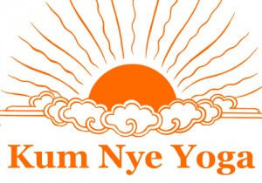

KUM NYE TIBETAN YOGA

Residential Retreat in France

From the 20th to the 26th of August, with Arnaud Maitland
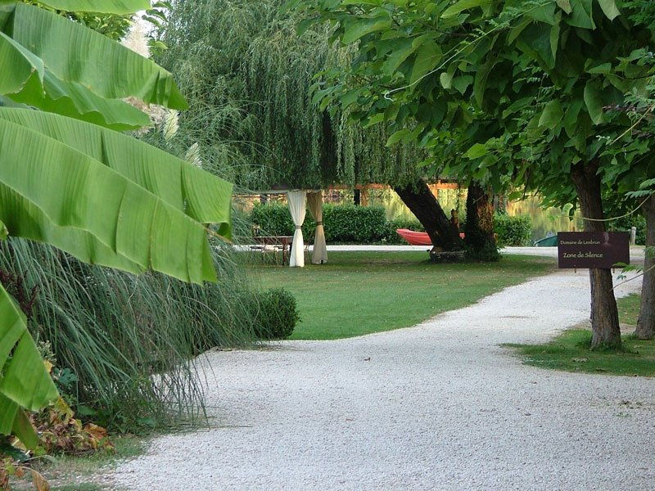

We invite you to participate to this retreat
Where we will explore
How to get the power of time on our side,
using Kum Nye.

For one week, we will explore how to get the power of time on our side, using Kum Nye. In Tarthang Tulku Rinpoche's books, much attention is being given to the topic of Time, both philosophically and very simply, practically. Most of us experience time as an outside force, if not an outright enemy, that in the end will be the victor when it's time for us to pass on.
In daily life, we are often stressed because we are out of sync with time. Our minds may be preoccupied with the past or try to anticipate what the future will bring, which both take us away from the present experience. In the subtle body energy system of Kum Nye, the chakras play a vital role. Each chakra has its distinctive characteristics, abilities, and strengths, as well as its typical connection to time. Like an orchestra, all chakras need to work in harmony for us to be aligned with time.
In Tarthang Tulku Rinpoche's books, we read, "With time on our side, everyone can be a hero or heroine." Kum Nye practices bring the rhythms and frequencies of the chakras in harmony with time. We learn to draw from the energy and knowledge that time embodies. Please join us for one week of study and practice, so that you can learn to relax in the tension of daily life and use time to your advantage and have it become an ally.

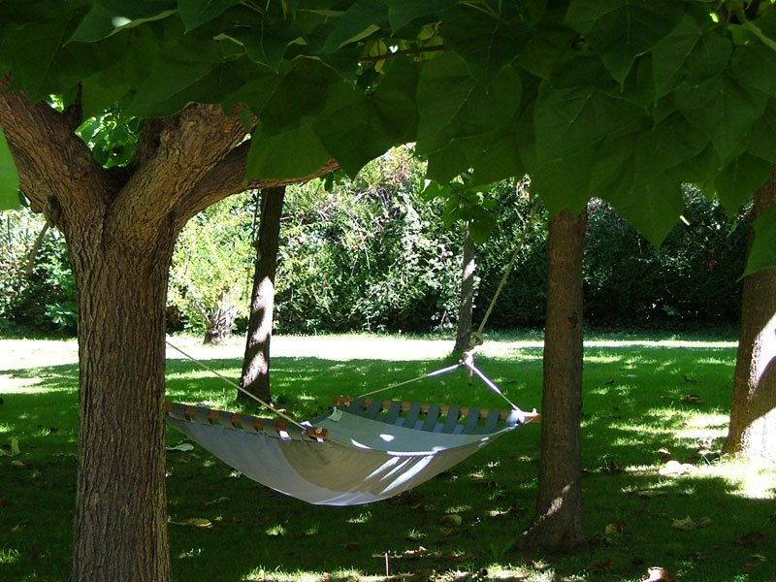

The Tibetan yoga Kum Nye is a millenary meditative practice based on mindfulness. By integrating mind and body, we can develop qualities which enable an inner balance. A deep and refined exploration to discover and use the mind talents in a more productive way.

To know further about this yoga, you can look at: http://kumnyeyoga.com

The teacher
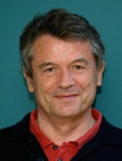
Arnaud Maitland JD. MA in Tibetan Buddhist philosophy and psychology.
He has been the student of Tarthang Tulku since more than 30 years and he is in charge to transmit Kum Nye in Europe. Arnaud is an international speaker, a director of retreats and he wrote ’Living without regret’’ (2006) and Masterwork (2000). Now Arnaud is director of Dharma Publishing.

The founder
Tarthang Tulku has studied buddhist tradition in Tibet. He is recognized internationally as an innovative teacher and a visionary thinker.
After ten years in India where he taught and published rare Tibetan texts, Tarthang Tulku settled down in United States in 1969 where he presents the benefits of buddhist philosophy to the westerners. In 1973, he has founded in Berkeley (California) the Nyingma institute where he established a method of deep relaxation, based on the knowledge of medical doctrine and therapies of his country, which enables to harmonize et stimulate the physical and psychic capacities.

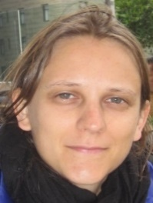
The translator
Sandy Hinzelin is an authorized Kum Nye Teacher and has a Phd in Philosophy. She has participated to several study and practice workshops in India, Nepal and United-States; has taught during six years east and west philosophy at the university; and has translated Joy of Being written by Tarthang Tulku, in collaboration with Arnaud Maitland.

The retreat is organized by the association Yoga Tibétain Kum Nyé France
Tel 06 84 77 70 29 / 07 80 89 18 09
Mail kumnye.france@gmail.com
Website www.yogatibetain.com

Where is the retreat ?
Domaine de Lembrun, Centre d’arts martiaux
47110 Le Temple-sur-Lot, France
Tel : +33 (0)5 53 40 50 50
Mail : lembrun@hotmail.com

Beginning of the retreat : Sunday, August 20th
Reception in the afternoon, Dinner at 7.30pm
End of the retreat: Saturday, August 27th after lunch

Please bring your yoga mat and cushion
Teaching by Arnaud Maitland in English, French translation by Sandy Hinzelin

Teaching fees :
 | Mensual income < 1600€ | Mensual income > 1600€
Teaching | 370€ | 475€

Arnaud wants to specify that the fees of the seminar, minus the organization expenses, are dedicated to the printing of sacred texts in order to preserve dharma, via Dharma Publishing.
Accommodation :
Double room without bathroom in the room | 330€/person/week
Summer cottage for 2 people, with bathroom | 360€/ person/week
Summer cottage for one person, with bathroom | 540€/ person/week
Summer cottage or mobil home for 4 people | 600€ + 180€/ person/week for the board
Lodge | 270€/ person/week
Camping | 228€/ person/week

Booking:
- Accommodation part : Please contact le domaine de Lembrun
Email lembrun@hotmail.com, tel. : 05 53 40 50 50
- Teaching part : Please send to the Association Kum Nyé France
- A filled register form
by email : kumnye.france@gmail.com
or by mail : B. Belgacem 2 rue de Colmar 63000 Clermont-Fd, France
- 120 € deposit by bank transfer (see below the bank references)

There will be an additional fee of 30€ if the registration is done after the 31th of May
Registration Form

Residential Retreat in France
From the 20th to the 26th of August au Domaine de Lembrun
Name, Family Name
Email address
Address
Telephone number
Teaching Price
Subscription : 10€
Deposit | 120 euros par virement

BANK DETAILS of KUM NYE France
ETABLISSEMENT: 20041 / GUICHET: 01003 / N°COMPTE: 0723987Z024 / CLE RIB : 50
DOMICILIATION : Banque postale Centre Financier 87900 LIMOGES CEDEX 9
IBAN- International Bank Account Number: FR24 2004 1010 0307 2398 7Z02 450
BIC – Bank Identifer Code: PSSTFRPPCLE
ACCOUNT OWNER: KUM NYE FRANCE

